

RAD Master Document

RAD DEVELOPMENT

The Imposters | Rapid App Development | 05/11/2020 - 10/12/2020

tABLE OF cONTENTS

Sprint 1 1

Meeting Minutes 2

Meeting Minutes 3

Agenda Items 3

Source Control Snapshot and History 4

Source Control Snapshot 5

Source Control History 6

Project Management Plan 10

Project Management Plan Snapshot 11

Software Development Testing Plan 12

Introduction 13

Scope 13

In Scope 13

Out of Scope 13

Quality Objective 13

Roles and Responsibilities 14

Test Methodology 15

Overview 15

Test Levels 15

Bug Triage 15

Suspension Criteria & Resumption Requirements 16

Test Completeness 16

Test Deliverables 17

Resource & Environment Needs 17

Testing Tools 17

Test Environment 17

Hardware Environment 17

Required Software 17

Terms / Acronyms 18

Analysis Report 19

CITE Business Rules 20

CITE Managed Services QA 21

A.E. Development Requirements 21

Multi-Platform Report 22

Responsive vs Adaptive 23

Our Decision 24

Code Testing 25

PHP_CodeSniffer Snapshots 26

Sprint 2 28

Meeting Minutes 29

Meeting Minutes 30

Agenda Items 30

Source Control Snapshot and History 31

Source Control Snapshot 32

Source Control History 33

Project Management Plan 37

Project Management Plan Snapshot 38

Software Review Plan 39

Performance Report 42

Website Performance 43

PHP CodeSniffer 48

Software Development Testing Plan 51

Test Table 52

Sprint 3 54

Meeting Minutes 55

Meeting Minutes 56

Agenda Items 56

Source Control Snapshot and History 57

Source Control Snapshot 58

Source Control History 59

Project Management Plan 63

Project Management Plan Snapshot 64

Optimisation Report 65

Performance Optimisation 66

Client-side and Server-side Optimisation 66

Client-side Performance Optimisation 67

Software Development Testing Plan 68

Updated Test Table 69

Exit Criteria 69

Conclusion 70

Code Testing 71

PHP CodeSniffer Snapshots 72

Sprint 1

Team Name : The Imposters

Scrum Master (#1) : Lisa Mckenna

Team Member (#2) : Swen Lee

Team Member (#3) : Daniel Ewen

Meeting Minutes

Meeting Minutes for Sprint One

Location : Murdoch T101 Office

Date : 5th November 2020

Time : 9:00 a.m.

# Meeting Minutes

Items discussed during team meeting in sprint one

## Agenda Items

1. Discuss design options (adaptive or responsive)
2. Discuss client requirements
3. Allocate tasks:
   * Develop master document
   * Set up GitHub repository
   * Develop analysis report
   * Develop project management plan
   * Develop multi-platform report
   * Develop software testing plan
   * Update website according to client requirements
   * Finalise documentation (update master document)

|  |  |  |  |
| --- | --- | --- | --- |
| Action Items | Owner(s) | Deadline | Status |
| Develop Master Document | Swen | 11/11/2020 | In Progress |
| Set up GitHub Repository | Daniel | 05/11/2020 | Complete |
| Develop Analysis Report | Swen | 11/11/2020 | In Progress |
| Develop Project Management Plan | Team | 05/11/2020 | Complete |
| Develop Multi-platform Report | Lisa | 11/11/2020 | In Progress |
| Develop Software Testing Plan | Daniel | 11/11/2020 | In Progress |
| Update website | Daniel | 11/11/2020 | In Progress |
| Finalise Documentation | Swen | 11/11/2020 | Pending |

Source Control Snapshot and History

Contains snapshot for github as well as the progress of the work

# Source Control Snapshot

Below is the snapshot for of our GitHub repository. Click [here](https://github.com/Devarthran/ImpostersRAD) to access it.

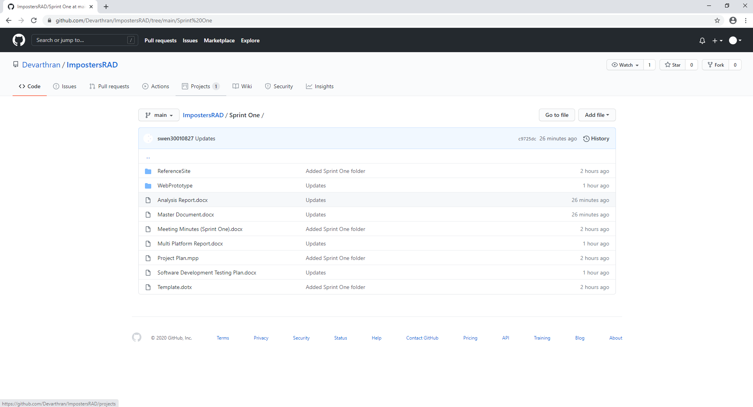

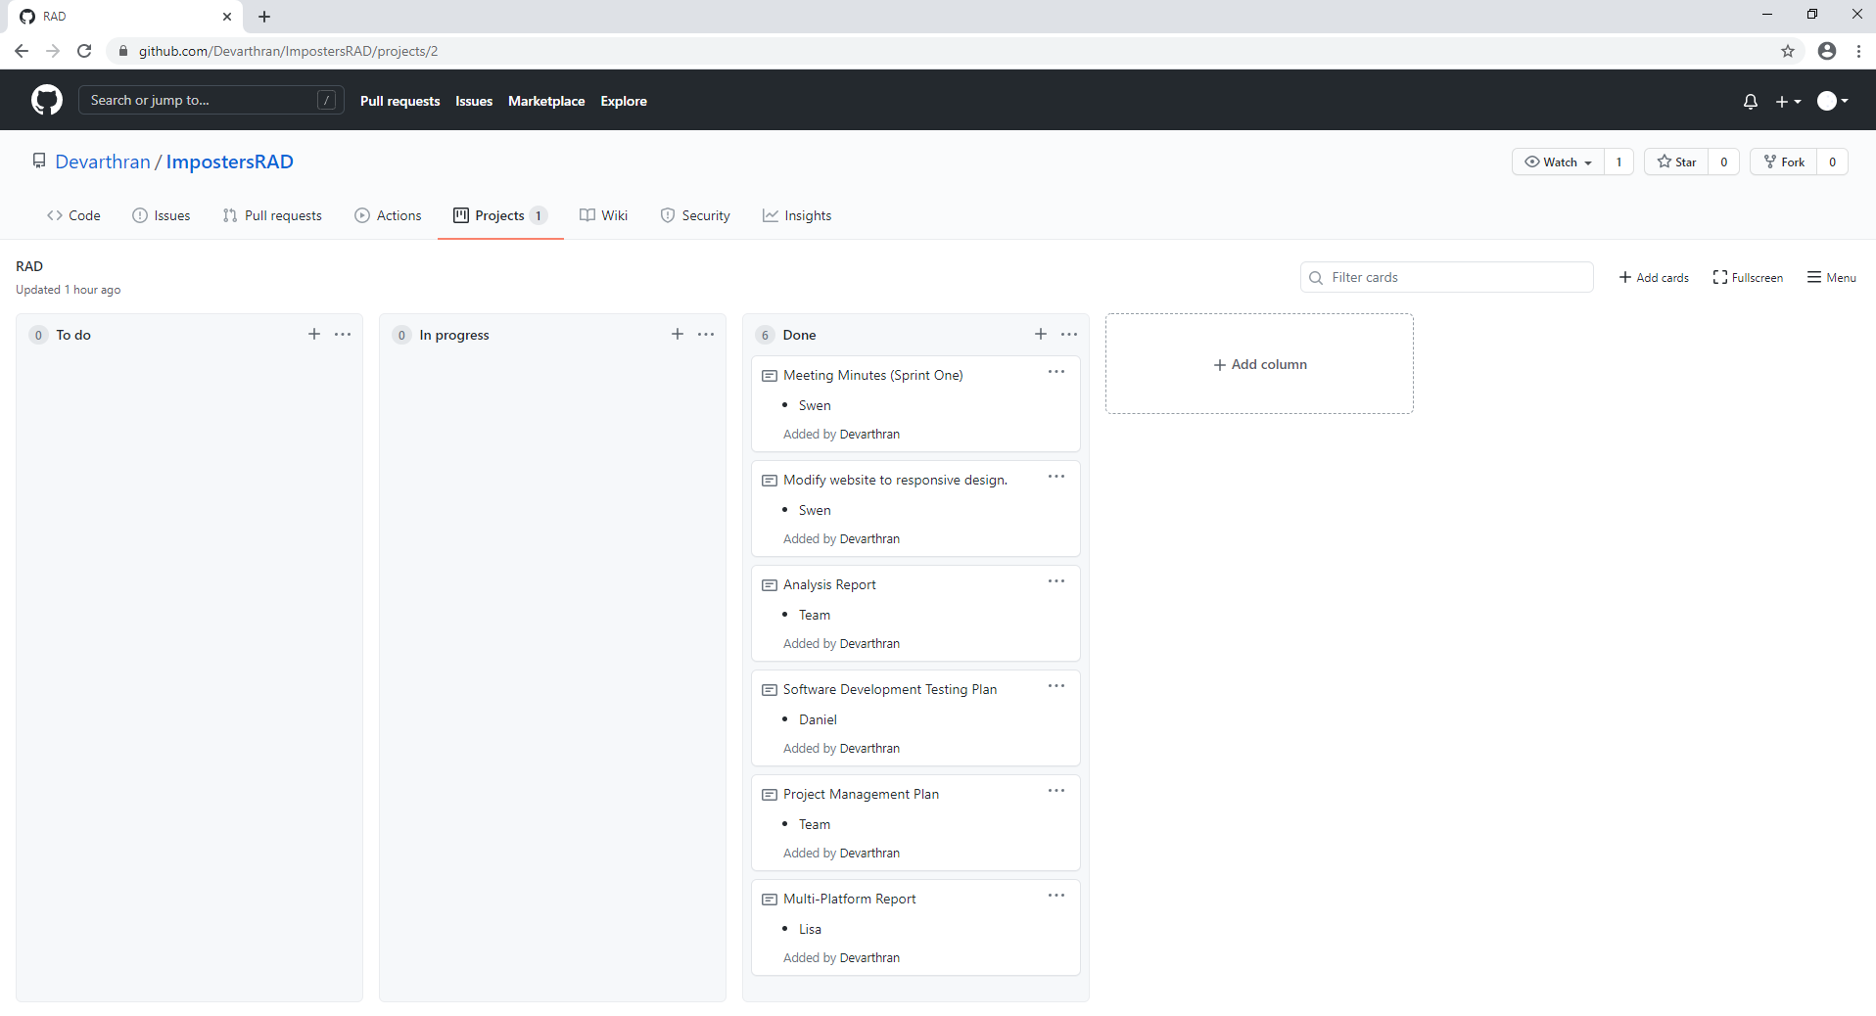

# Source Control History

|  |  |
| --- | --- |
| Date | Evidence |
| 05/11/2020 (Thursday) | Ref 1 |
| 06/11/2020 (Friday) | Ref 2 |
| 09/11/2020 (Monday) | Ref 3 |
| 10/11/2020 (Tuesday) | Ref 4 |
| 11/11/2020 (Wednesday) | Ref 5 |

Ref 1

1. 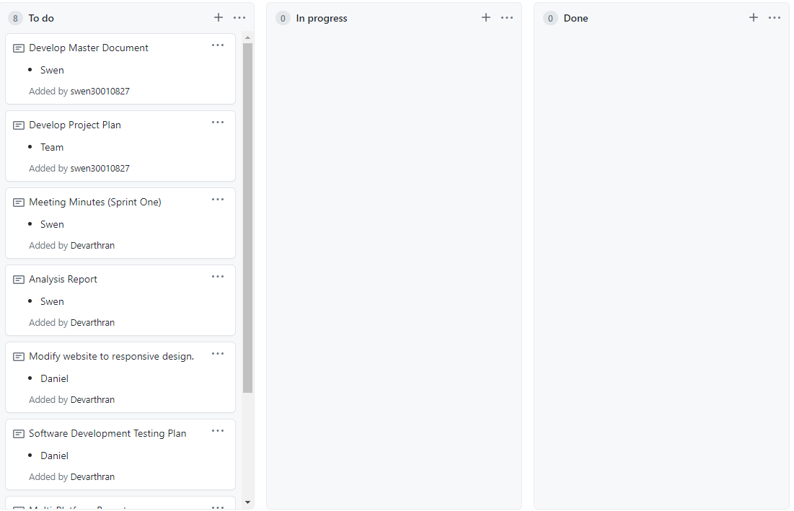
2. 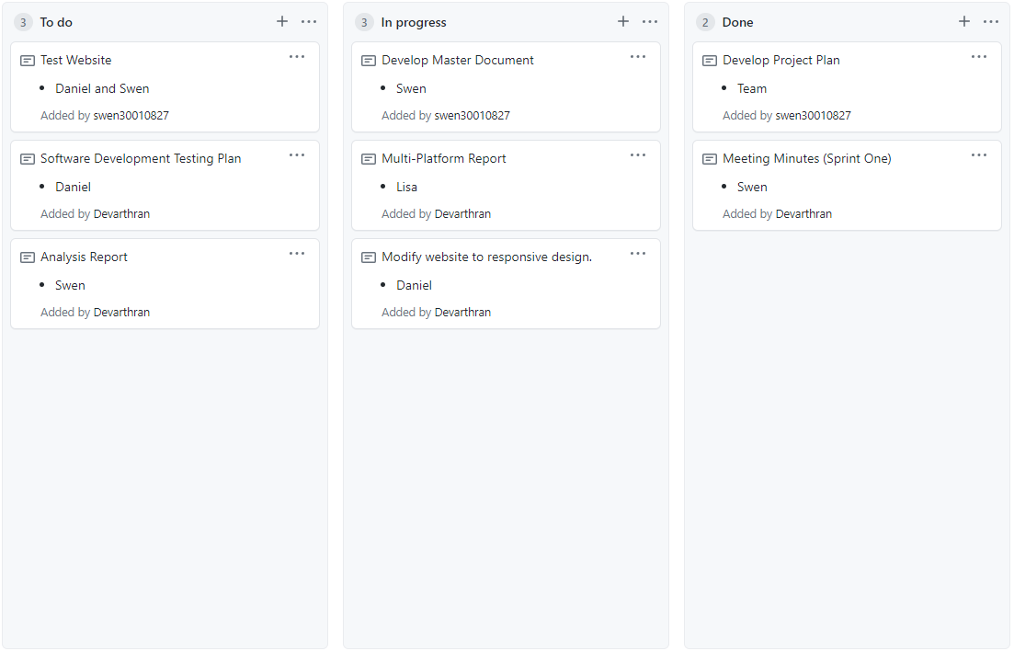

Ref 2

1. 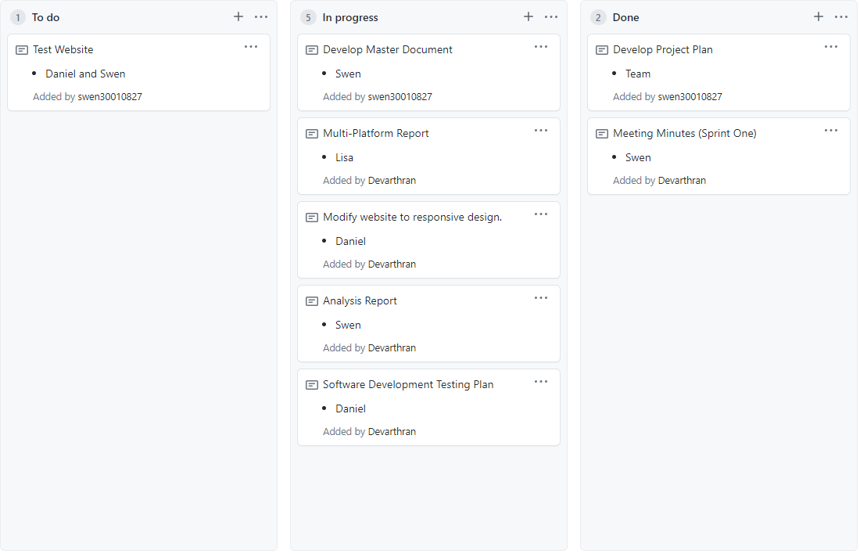

Ref 3

1. 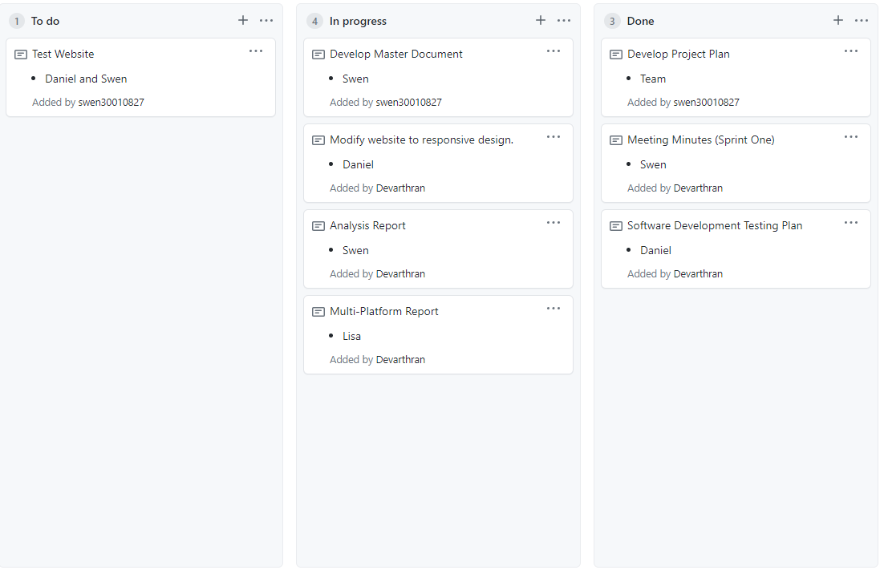

Ref 4

1. 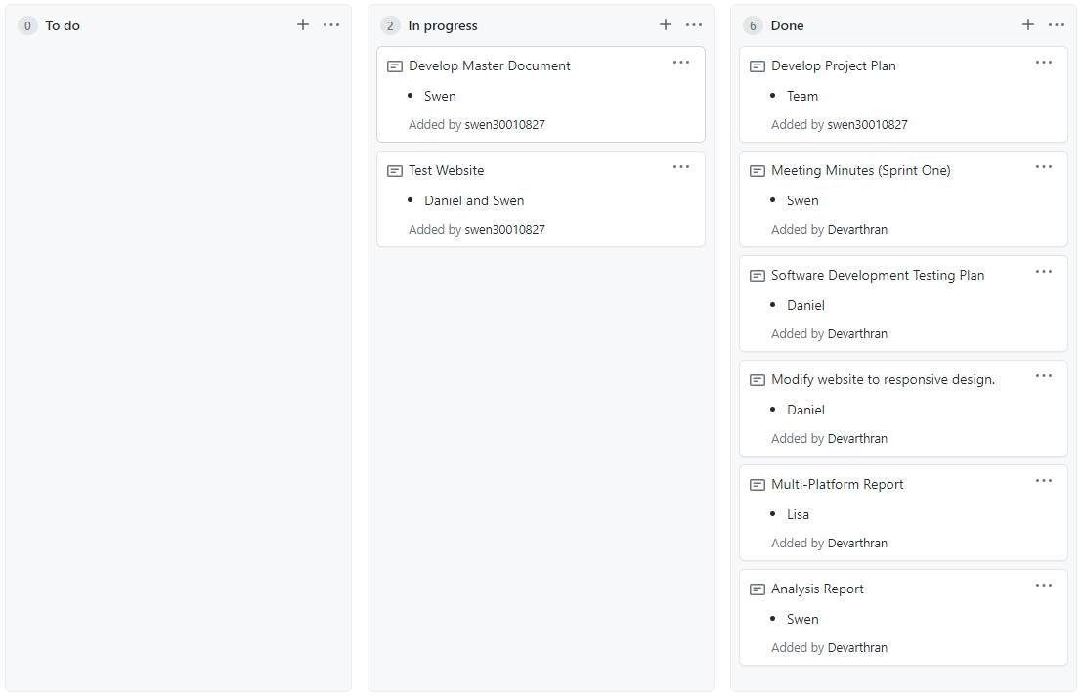

Ref 5

1. 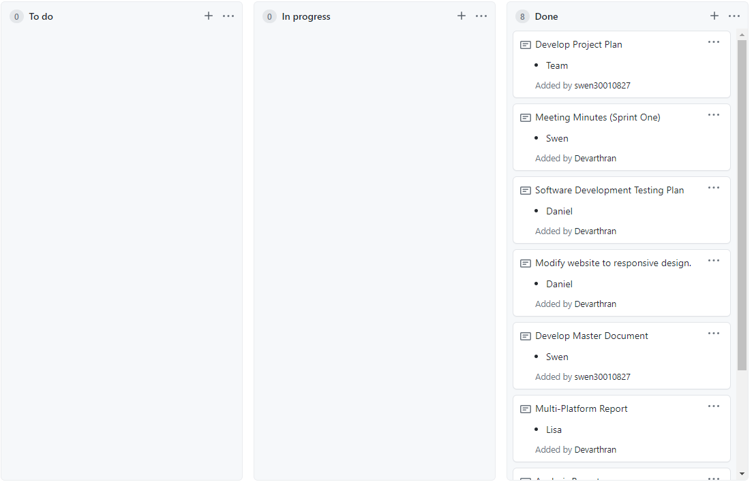

Project Management Plan

Contains the project management plan for sprint one

# Project Management Plan Snapshot

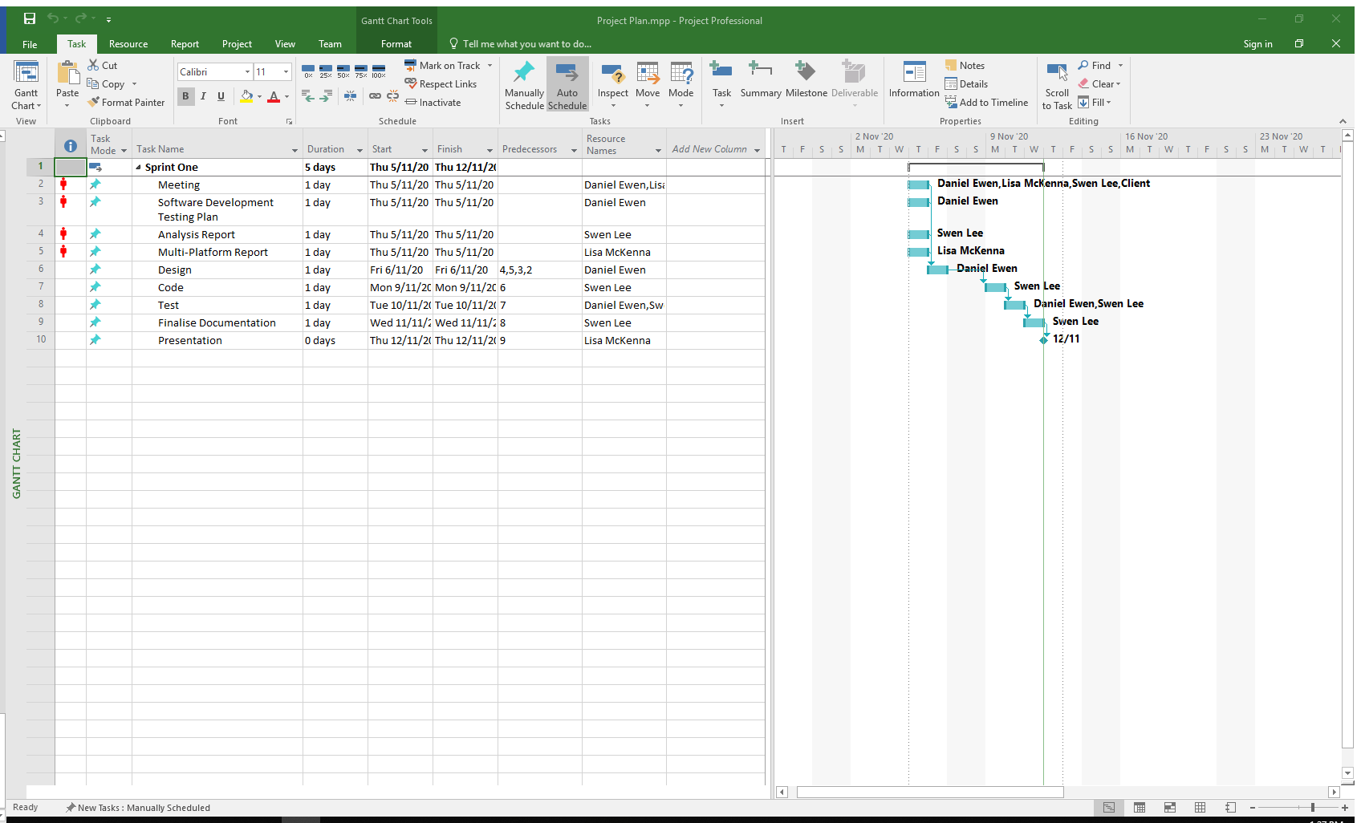

Software Development Testing Plan

Develop a test plan for the project

CHANGELOG

|  |  |  |  |
| --- | --- | --- | --- |
| Version # | Date of change | Change by | Outline |
| 1.0 | 5/11/2020 | Daniel Ewen | Test Plan Creation |
|  |  |  |  |
|  |  |  |  |
|  |  |  |  |

# Introduction

## Scope

### In Scope

Features to be tested:

* Application design is responsive
* User Interface
* Interface responds in real-time
* Database migrates correctly to the new design.

### Out of Scope

Features that won’t be tested:

* Movie database

## Quality Objective

Our team’s objective is to deliver a working prototype to the client with the following qualities:

* AUT* must conform to the client’s requirements for each sprint.
* AUT must meet the client’s quality standards.
* Bugs/defects are tested and fixed before the application is deployed for the client.
* The AUT meets coding and commenting standards defined by each coding language standard.

## Roles and Responsibilities

|  |  |
| --- | --- |
| Role | Description |
| Developers | Research, design, implement and manage software programs |
| Test Manager | Organise and control the testing process to deliver a high-quality software |
| QA analyst | Test software on other computers to ensure they are functioning accurately |
| Business Analyst | Connect IT and business using data analytics and determine client requirements |
| Bug Triage | Evaluate, prioritise and assign resolution defects |

# Test Methodology

## Overview

Our team will utilize the RAD* test methodology throughout this project. Each sprint will seek to develop, test, and deliver a fully functioning prototype to the specification of the client.

## Test Levels

Our testing team will implement the following test types for this project:

* Exploratory Testing
* Functional Testing
* Accessibility Testing
* Compatibility Testing
* Integration Testing
* System testing
* User Acceptance Testing (UAT)

## Bug Triage

Our process for bug/defect triage is as follows:

* **Bug discovered:** Bug report is added to the bug list. For this our team will use the issue tracker built into GitHub, detailing the bug.
* **Investigate:** Developers read the report and try to replicate the bug. If replication occurs, the bug can then be prioritized.
* **Bug added to backlog:** Bug is awaiting resolution during sprint.
* **Resolved:** Bug is fixed during development and the issue is closed.

## Suspension Criteria & Resumption Requirements

During testing, should any test return more than a 30% fail the following should occur:

* Testing ceases
* Test case / module being tested investigated for design flaws
* If bugs are discovered, add them to the triage queue.
* Once the bug has resolved in the triage queue, run the test again.

## Test Completeness

Testing will be complete when:

* The AUT has been deemed to have 100% test coverage,
* All designed test cases return with a pass,
* All current bugs/issues have been resolved,
* The client is satisfied with the current condition of the AUT and has signed off on its deployment.

# Test Deliverables

|  |
| --- |
| Deliverables |
| Test Plan |
| Test Cases with validation |
| Requirements |
| Analysis Report |
| Bug Reports |
| Client Sign-off |

# Resource & Environment Needs

## Testing Tools

* **Chromium developer tools:** Exploratory testing and during development.
* **PHP_CodeSniffer:** Checks the PHP code for syntax and standards errors.

## Test Environment

### Hardware Environment

A modern development workstation with the following minimum specifications:

|  |
| --- |
| Part |
| Intel CPU 4-cores or more with hyperthreading |
| 16GB DDR4 RAM 2600MHz |
|  |

### Required Software

|  |  |
| --- | --- |
| Software | |
| Xampp | Local webserver and database hosting |
| Visual Studio Code | Code and application development |
| GitHub Desktop | Source Control |

# Terms / Acronyms

|  |  |
| --- | --- |
| Term / Acronym | Definition |
| RAD | Rapid Application Development |
| AUT | Application Under Test |

Analysis Report

describes CITEMS Rules, Quality Assurance Practices and Acme’s Development Requirements

# CITE Business Rules

Describes the CITE Business Rules for Software Development

At CITEMS we adhere to our business rules which consist of:

* Prioritising client interests
* Operate in an ethical manner in regards to the regulations
* Uphold accountability during software development
* Always strive to achieve a better solution to a client’s issues
* Prioritise firm and client interests
* Be fair competitors and not degrade other firms
* Maintain high ethical standards
* Abide by coding policies and standards

# CITE Managed Services QA

CITE Managed Services (CITEMS) Quality Assurance Practices

According to the [CITEMS](http://www.citems.com.au/?page_id=84) website, our organisation has launched processes which evaluate the project’s performance as well as ensure that quality standards are being followed and that the deliverables meet the client’s requirements.

Some of our quality assurance practices include:

* Conduct full-cycle quality assurance testing
* Document and code reviews
* Defect tracking
* Configuration management
* Process monitoring
* Risk management

CITEMS conducts quality assurance throughout the development lifecycle with our QA team members engaged in every stage. A standard QA lifecycle at CITEMS will involve the following stages:

1. Initiation and Planning – Project specification analysis, test plan explanation and team assignment
2. First review – Early testing of first development deliverables, refining test plan as well as test items (if required)
3. Iteration audits – Ongoing test of intermediate iteration builds
4. Final verification and validation – Final product testing to guarantee bespoke quality and readiness for deployment

# A.E. Development Requirements

Acme Entertainment Pty Ltd Development Requirements

* Acme Entertainment have commissioned a prototype movie database, however, this application is required to be updated to meet the following requirements:
* Able to use across all major digital platforms

Multi-Platform Report

Describes the difference between adaptive and responsive design

# Responsive vs Adaptive

Responsive sites and adaptive sites are the same in that they both change appearance based on the browser environment they are being viewed on.

Responsive websites respond to the bowser no matter what the browser width may be, the site adjusts its layout (and perhaps functionality) in a way that is optimised to the screen.

Adaptive websites are only concerned about the browser being a specific width, at which point it adapts the layout.

The simplest way to view this is the difference between smooth and snap design. Responsive design is smooth because the layout fluidly adjusts regardless of what device it is viewed on. Adaptive design, on the other hand, snaps into place because the page is serving something different because of the browser or device it is viewed on.

Here’s an image comparing responsive and adaptive designs from [Medium](https://popart-studio.medium.com/fluid-vs-adaptive-vs-responsive-design-62de51e036bd).

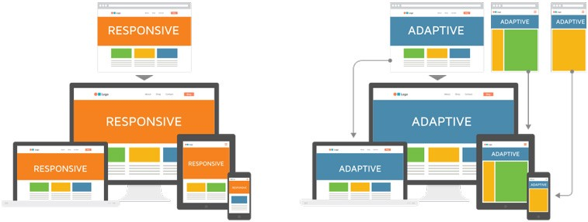

In the example above the responsive picture flows with the environment whereas the adaptive snaps into place at a defined environment.

Responsive design is both fluid and flexible which is a means of becoming device agnostic in the sense that it seeks to create an optimised experience for any screen.

Essentially, we challenge ourselves to create sites that shift context according to how a site is being consumed on any given occasion.

Compare that with an adaptive way of thinking, which is neither fluid nor flexible, but looks for specific points at which to adapt. While it might be difficult to adapt a website on all the various devices being used today.

Both responsive and adaptive designs are similar in the way that they are methods for dealing with the reality that websites are often viewed on different devices in different contexts. They just go about this in different ways.

(Graham, 2015)

# Our Decision

Our team’s recommendation is the responsive design, where we have produced a prototype application. As technology is ever changing and moving at a rapid pace, the responsive prototype is delivering a design that is both fluid, flexible and able to adjust its layout and perhaps its functionality in a way that it is optimised to the screen, there for, it can be view on current and future devices. In turn this will future proof the business where it is able grow exponentially

Code Testing

use php_codesniffer to test and fix errors on the website

# PHP_CodeSniffer Snapshots

index.php

1. Text

   Description automatically generated
2. Graphical user interface

   Description automatically generated

search.php

1. Text

   Description automatically generated
2. A picture containing timeline

   Description automatically generated

genre_scr.php

1. Text

   Description automatically generated
2. A picture containing text

   Description automatically generated

rating_scr.php

1. Text

   Description automatically generated
2. Graphical user interface, text

   Description automatically generated

top10.php

1. Text

   Description automatically generated
2. Graphical user interface, text

   Description automatically generated

Sprint 2

Team Name : The Imposters

Scrum Master (#1) : Swen Lee

Team Member (#2) : Daniel Ewen

Team Member (#3) : Lisa Mckenna

Meeting Minutes

Meeting Minutes for Sprint Two

Location : Murdoch T101 Office

Date : 12th November 2020

Time : 12:00 p.m.

# Meeting Minutes

Items discussed during team meeting in sprint two

## Agenda Items

1. Discuss software review plan
2. Discuss client requirements
3. Allocate tasks:
   * Update GitHub repository
   * Update project management plan
   * Develop performance report
   * Develop software review plan
   * Update software testing plan
   * Update website according to client requirements
   * Finalise documentation (update master document)

|  |  |  |  |
| --- | --- | --- | --- |
| Action Items | Owner(s) | Deadline | Status |
| Update GitHub repository | Daniel | 12/11/2020 | Complete |
| Update Project Plan | Team | 12/11/2020 | Complete |
| Performance Report | Swen | 18/11/2020 | In Progress |
| Software Review Plan | Lisa | 18/11/2020 | In Progress |
| Update Software Testing Plan | Daniel | 18/11/2020 | In Progress |
| Update Website | Daniel | 18/11/2020 | In Progress |
| Finalise Documentation | Swen | 18/11/2020 | Pending |

Source Control Snapshot and History

Contains snapshot for GitHub as well as the progress of the work

# Source Control Snapshot

Below is the snapshot for out GitHub repository. Click [here](https://github.com/Devarthran/ImpostersRAD/tree/main/Sprint%20Two) to access it.

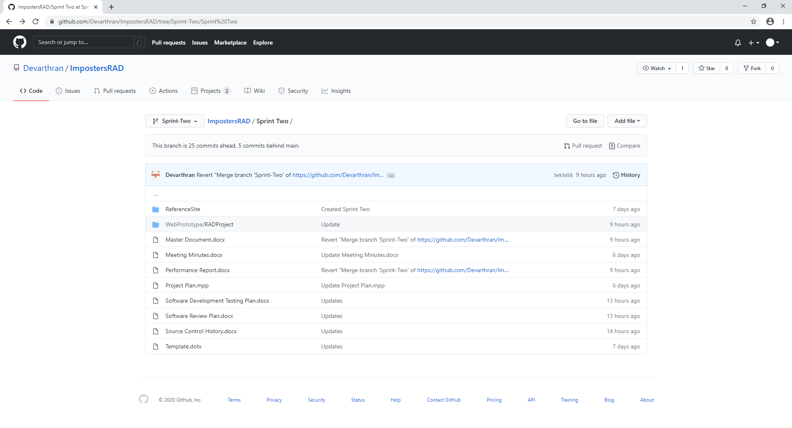

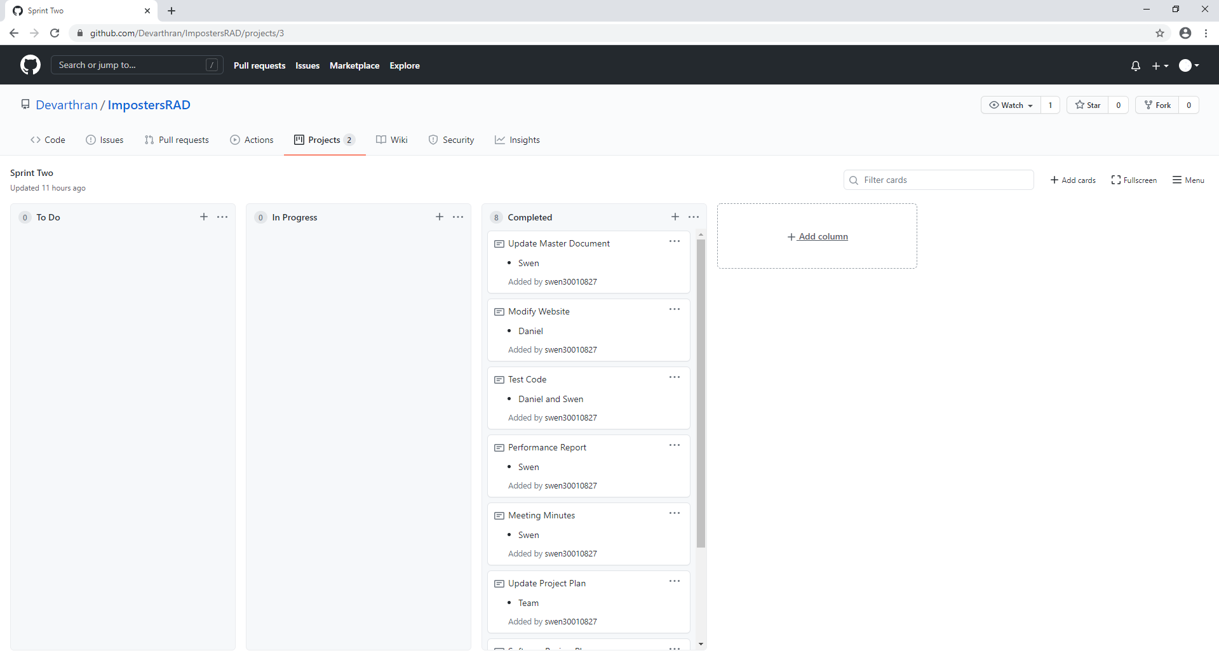

# Source Control History

|  |  |
| --- | --- |
| Date | Evidence |
| 12/11/2020 (Thursday) | Ref 1 |
| 13/11/2020 (Friday) | Ref 2 |
| 16/11/2020 (Monday) | Ref 3 |
| 17/11/2020 (Tuesday) | Ref 4 |
| 18/11/2020 (Wednesday) | Ref 5 |

Ref 1

1. Graphical user interface, application, Teams

   Description automatically generated
2. Graphical user interface, application

   Description automatically generated

Ref 2

1. Graphical user interface, application

   Description automatically generated

Ref 3

1. Graphical user interface, application

   Description automatically generated

Ref 4

1. Graphical user interface, application

   Description automatically generated

Ref 5

1. Graphical user interface, application, Word

   Description automatically generated

Project Management Plan

Contains the project management plan for sprint one

# Project Management Plan Snapshot

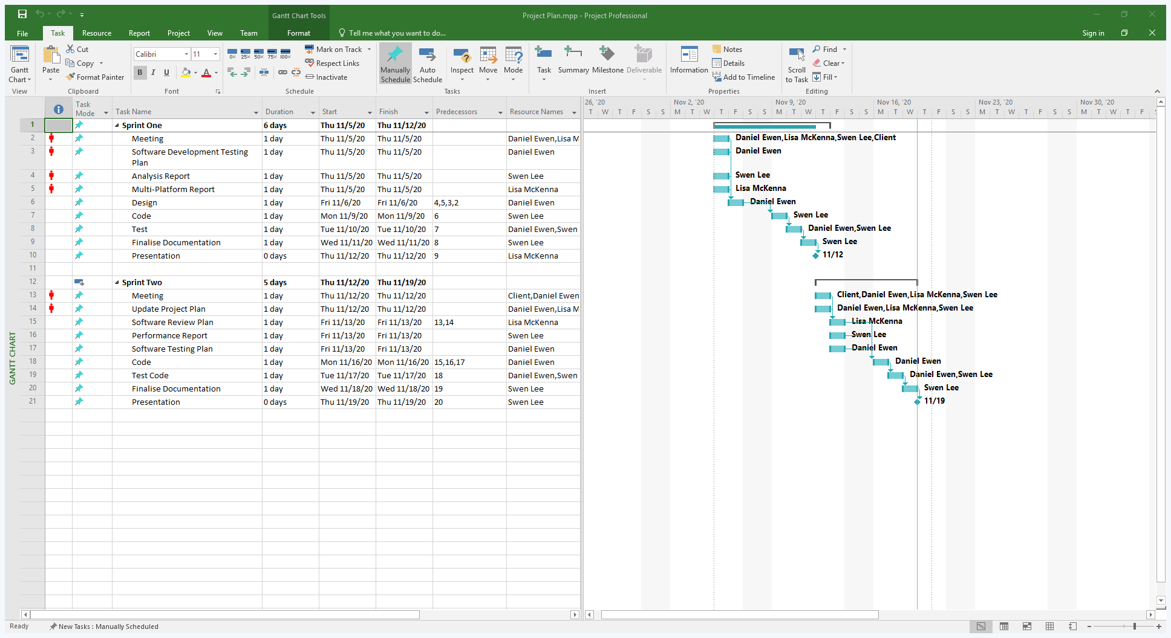

Software Review Plan

Development and Design

# Review Checklist

|  |  |  |
| --- | --- | --- |
| ID | Description | Status |
| 1 | Website has a front end |  |
| 2 | Website has a search page |  |
| 3 | Website searches according to conditions selected |  |
| 4 | User is able to sign up to subscribe for newsletter or notifications |  |
| 5 | Website has a profile page for users to sign in and change their subscription |  |
| 6 | User is able to unsubscribe as they please |  |
| 7 | User is able to rate the movies |  |
| 8 | Website displays a graph with the top 10 rated movies |  |
| 9 | Graph refreshes automatically |  |
| 10 | Website has a login page for administrators |  |
| 11 | Administrators are able to add, edit and delete users |  |
| 12 | Administrator passwords are secured |  |
| 13 | Administrator passwords pass a minimum complexity test |  |

Performance Report

Demonstrates the performance of the website has been measured

# Website Performance

The website’s performance was tested using the performance tool in Google Chrome’s Developer tools. The Chrome performance monitor records the website’s performance metrics while the page is running or reloading. The user is able to review and interact with snapshots of recordings. After a recording is taken, a graph is displayed with the summary of the website’s performance.

(BitDegree, 2019)

Home page (index.php)

Running the home page takes a relatively shorter period of time as it does not contain much code, it just contains the design and a few words for now.

1. 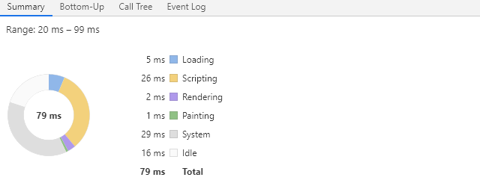

Search page (search.php)

1. According to the graph, rendering the search page takes up most of the time as the website is grabbing all the data from the database in one go and rendering it on the page.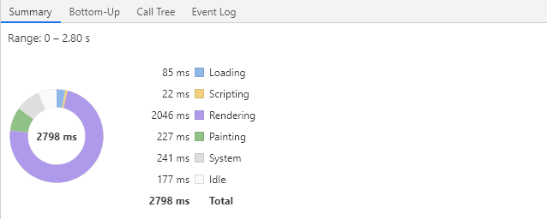
2. When searching, system uses most of the time as it is searching in the database for the information requested

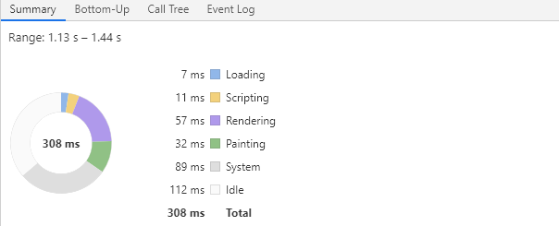

Top 10 Movies page (top10.php)

Scripting takes up most of the time on the top 10 movies page as jQuery and JavaScript is used to display the graph and execution of them takes up time.

1. 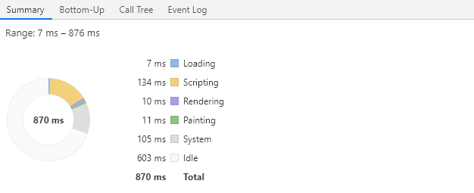

Sign Up page (signup.php)

1. Signing up to the page requires the system to load the data to the database, hence system takes up most of the time here.

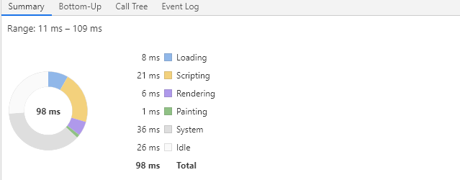

1. Signing up to the page requires the system to save the information to the database, hence, system takes up most of the time

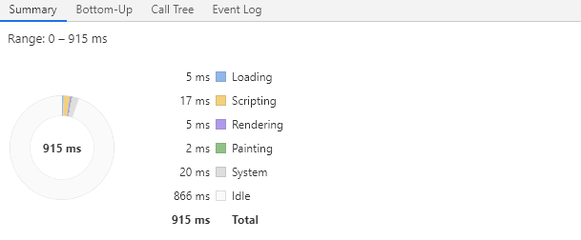

Login page (login.php)

1. Loading the login page doesn’t take up much time as it just contains a few text fields and buttons

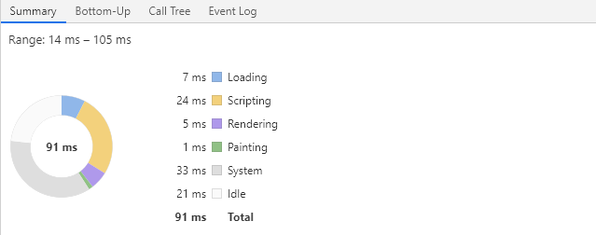

1. When logging in, the system takes up most of the time as it is required to load the database to ensure the credentials inputted are accurate

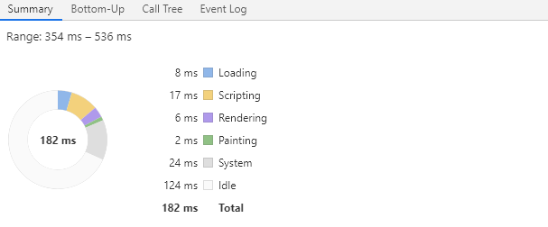

# PHP CodeSniffer

Home page (index.php)

1. 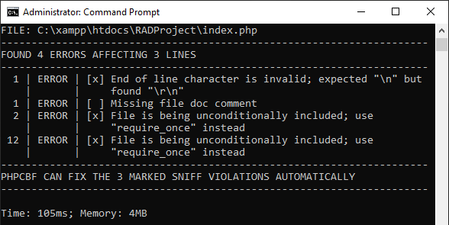
2. 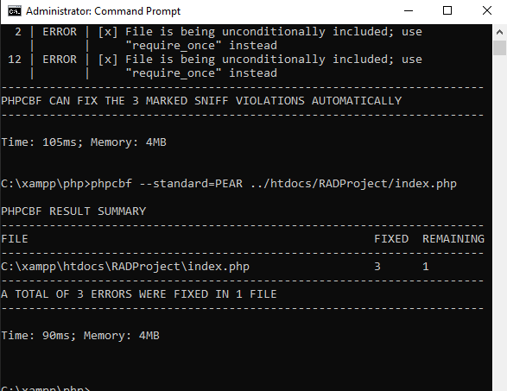

Search page (search.php)

1. 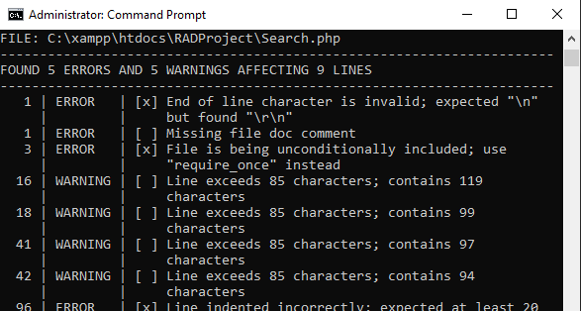
2. 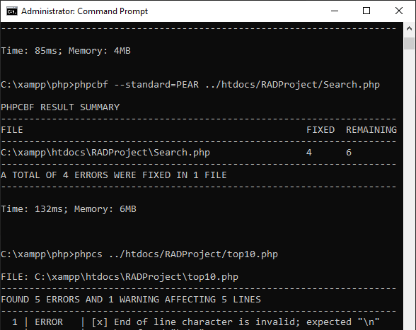

Top 10 Movies page (top10.php)

1. 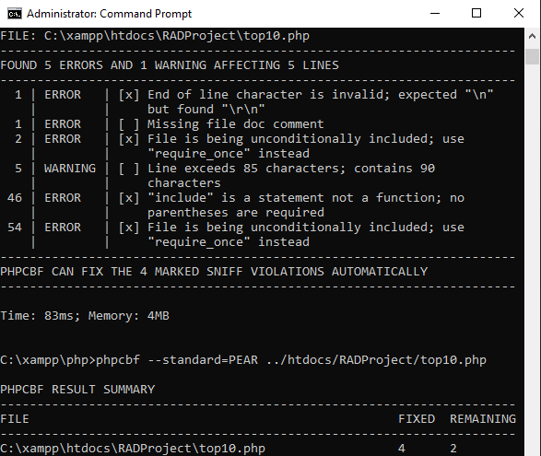
2. 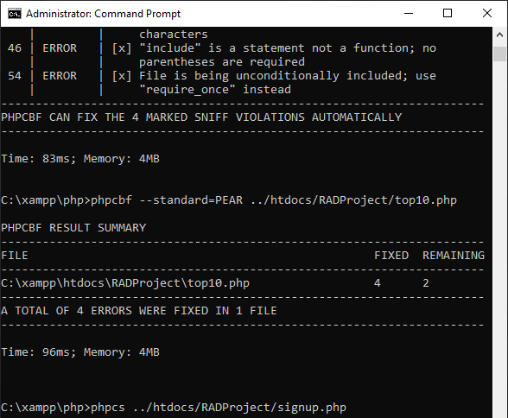

Sign Up page (signup.php)

1. 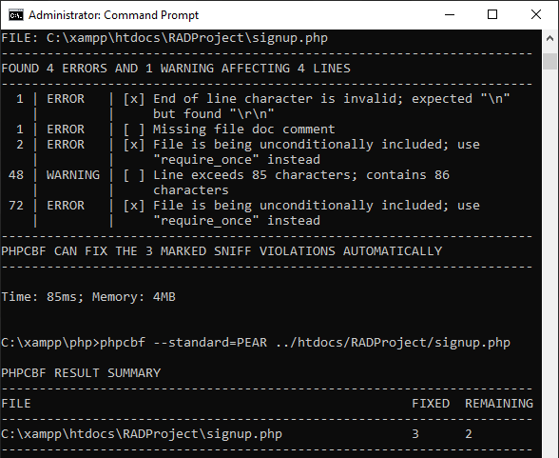
2. 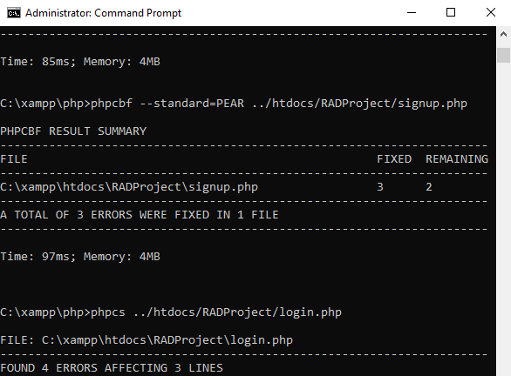

Login page (login.php)

1. 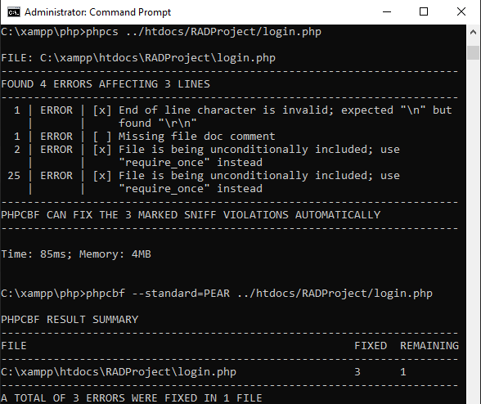
2. 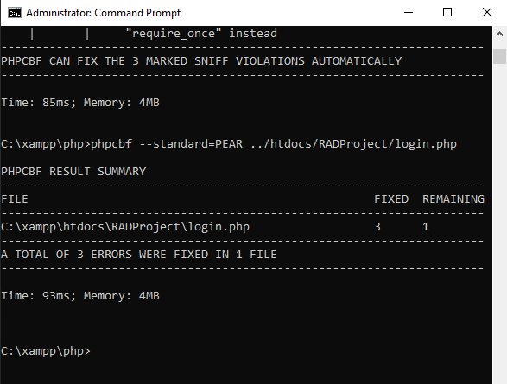

Software Development Testing Plan

UPDATE a test plan for the project

CHANGELOG

|  |  |  |  |
| --- | --- | --- | --- |
| Version # | Date of change | Change by | Outline |
| 1.0 | 5/11/2020 | Daniel Ewen | Test Plan Creation |
|  |  |  |  |
|  |  |  |  |
|  |  |  |  |

# Test Table

|  |  |  |  |  |
| --- | --- | --- | --- | --- |
| Test ID | Description | Expected Results | Actual Results | Pass/Fail |
| Precondition: Enter full name | | | | |
| 1 | User enters full name with letters | Full name entered into database | Full name entered into database | Pass |
| 2 | User enters full name with numbers | Full name not entered into database | Full name not entered into database | Pass |
| 3 | User enters full name with numbers, letters, characters | Full name not entered into database | Full name not entered into database | Pass |
| Precondition: Enter email address | | | | |
| 4 | User enters email address with @ and .com or .au | Email entered into data base | Email entered into data base | Pass |
| 5 | User enters email with @ only | Email not entered into database | Email not entered into database | Pass |
| 6 | User enters email with .com or .au only | Email not entered into database | Email not entered into database | Pass |
| Precondition: Communication option selection (monthly newsletter and/or breaking news flash notification as they occur) | | | | |
| 7 | Both communications selected | User receives both communications | User receives both communications | Pass |
| 8 | Monthly newsletter selected | User receives monthly newsletter | User receives monthly newsletter | Pass |
| 9 | Breaking newsflash selected | User receives breaking newsflash | User receives breaking newsflash | Pass |
| Precondition: Enter full name | | | | |
| 10 | Automatically sends email for removal of member details | Member details removed form database | Member details removed form database | Pass |

Sprint 3

Team Name : The Imposters

Scrum Master (#1) : Daniel Ewen

Team Member (#2) : Lisa Mckenna

Team Member (#3) : Swen Lee

Meeting Minutes

Meeting Minutes for Sprint THREE

Location : Murdoch T101 Office

Date : 19th November 2020

Time : 12:00 p.m.

# Meeting Minutes

Items discussed during team meeting in sprint three

## Agenda Items

1. Discuss client requirements
2. Confirm requirements with client
3. Allocate tasks:
   * Update GitHub repository
   * Update project plan
   * Develop software testing plan
   * Develop optimisation report
   * Update website according to client requirements
   * Finalise documentation (update master document)

|  |  |  |  |
| --- | --- | --- | --- |
| Action Items | Owner(s) | Deadline | Status |
| Update GitHub repository | Daniel | 19/11/2020 | Complete |
| Update Project Plan | Team | 19/11/2020 | Complete |
| Optimisation Report | Lisa | 25/11/2020 | In Progress |
| Update Software Testing Plan | Swen | 25/11/2020 | In Progress |
| Update Website | Daniel | 25/11/2020 | In Progress |
| Finalise Documentation | Swen | 25/11/2020 | Pending |

Source Control Snapshot and History

Contains snapshot for GitHub as well as the progress of the work

# Source Control Snapshot

Below is the snapshot for out GitHub repository. Click [here](https://github.com/Devarthran/ImpostersRAD/tree/main/Sprint%20Three) to access it.

# Source Control History

|  |  |
| --- | --- |
| Date | Evidence |
| 19/11/2020 (Thursday) | Ref 1 |
| 20/11/2020 (Friday) | Ref 2 |
| 23/11/2020 (Monday) | Ref 3 |
| 24/11/2020 (Tuesday) | Ref 4 |
| 25/11/2020 (Wednesday) | Ref 5 |

Ref 1

1. 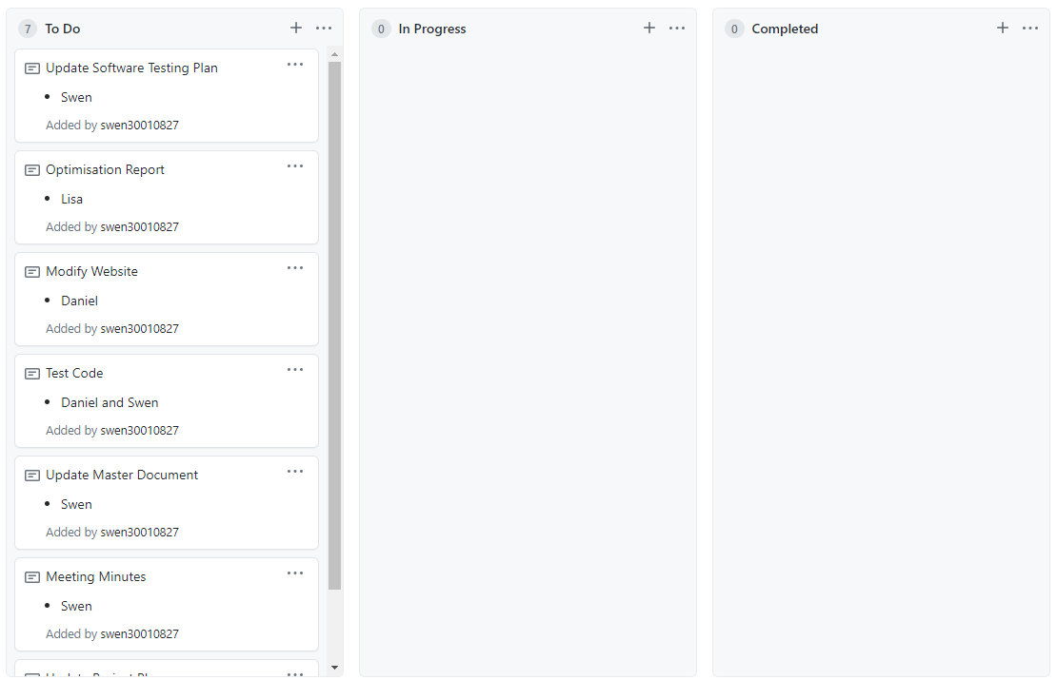
2. 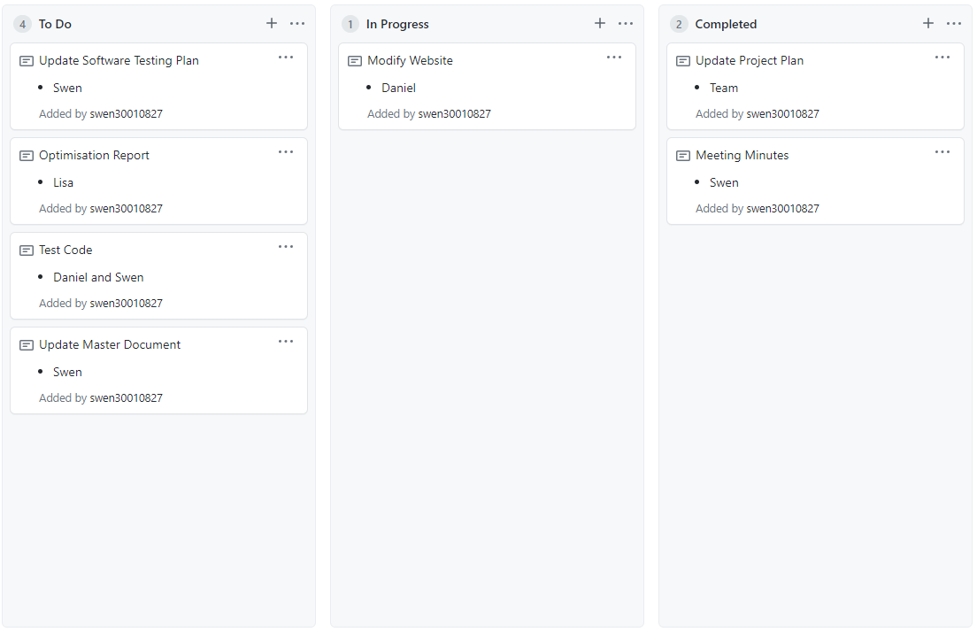

Ref 2

1. Graphical user interface, application

   Description automatically generated

Ref 3

1. Graphical user interface, application

   Description automatically generated

Ref 4

1. Graphical user interface, application, Teams

   Description automatically generated

Ref 5

1. Graphical user interface, application

   Description automatically generated

Project Management Plan

Contains the project management plan for sprint THREE

# Project Management Plan Snapshot

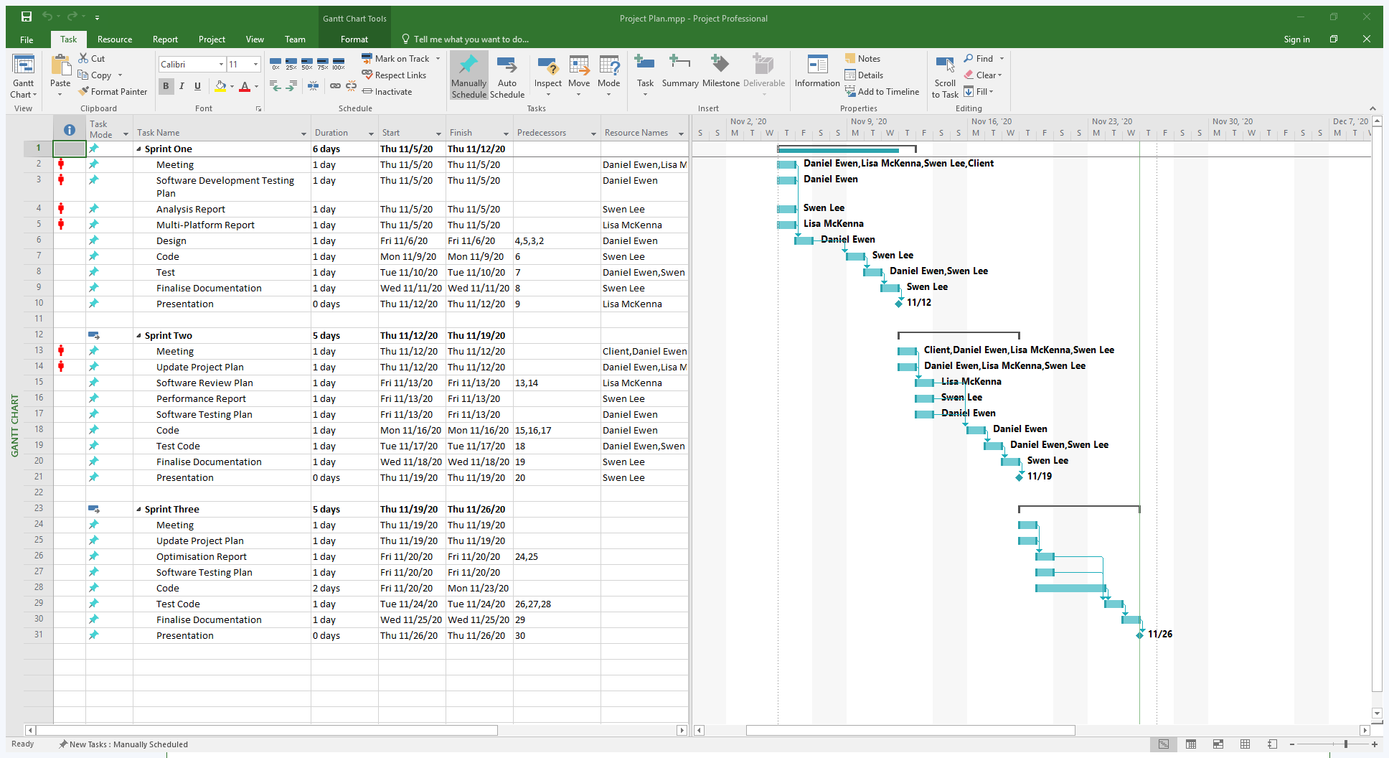

Optimisation Report

# Performance Optimisation

Performance optimisation is key in having an efficiently functional application and is executed by monitoring and analysing the performance of an application and identifying ways to improve it to work more efficiently and execute more rapidly.

At CITE we have identified the levels of optimisation to be focused on:

1. Design Level
   * + - The design of our system is making the best use of the available resources, given goals, and expected load.
       - The architectural design of our system plays an important role on affecting system performance.
       - Optimise the system to minimize network requests, ideally making a single request rather than multiple requests.
2. Algorithms and Data Structures

* Algorithm and data structures are key players, being crucial to the systems performance.
* To ensure our system is optimised, we are making sure the algorithms are constant, logarithmic, linear, or log linear.
* We are implementing abstract data types as they are more efficient for system optimisation.

1. Source Code Level

* On our implementation of algorithms, along with our source code choices are quite crucial on system optimisation.

## Client-side and Server-side Optimisation

Our client-side relates to how the performance is seen on the web browser or the user interface. This includes page load time, downloading of all resources, image load time etc.

Our server-side relates to how long it takes to run on the server to execute requests. Optimising our performance on the server generally involves Optimising the database queries and other application dependencies.

## Client-side Performance Optimisation

Below are some of the ways we are optimising performance on the client side:

1. Content Delivery Network

* The content delivery networks are an intelligent way that we are handling our static files like JavaScript, CSS and image files which do not change.

1. Bundle and Minification

* Bundling our files together and producing fewer files improves performance.
* Minifying our files and removing all unnecessary characters e.g. white spaces also improves our performance

1. Optimising Image Usage

* Most of our images can be optimised and made smaller

1. Removing duplicate code JavaScript and CSS

* Removing our duplicate code reduces the size of the files hence better performance.

1. Using a Minimalistic Styling Framework

* This will help with our styling aspect and as the styling framework has already been optimised and minified for better performance it should be effective in keeping the performance of our system optimal.

Software Development Testing Plan

UPDATE test plan for the project

|  |  |  |  |
| --- | --- | --- | --- |
| Version # | Date of change | Change by | Outline |
| 1.0 | 5/11/2020 | Daniel Ewen | Test Plan Creation |
| 1.1 | 16/11/2020 | Lisa McKenna | Update Test Plan for Sprint 2 |
| 1.2 | 23/11/2020 | Swen Lee | Update Test Plan for Sprint 3 |
|  |  |  |  |

# Updated Test Table

|  |  |  |  |  |
| --- | --- | --- | --- | --- |
| Test ID | Description | Expected Results | Actual Results | Pass/Fail |
| Precondition: Administrator enters username and password | | | | |
| 11 | Login as administrator with correct credentials | Able to access and edit database | Able to access and edit database | Pass |
| Precondition: N/A | | | | |
| 12 | Click on ratings page | Display the top 10 rated movies | Display the top 10 rated movies | Pass |
| 13 | Remain at the top 10 ratings page | Refreshes the page automatically every few minutes | Refreshes the page automatically every few minutes | Pass |
| 14 | Search for historical ratings | Display historical charts of the top 10 rated movies | Display historical charts of the top 10 rated movies | Pass |

# Exit Criteria

Exit criteria defines when to stop the testing process, for example, when a set of tests has achieved its objective.

Exit criteria may involve:

* Estimates of defect density or reliability measures
* Cost
* Residual risks (e.g. unfixed bugs)
* Thoroughness measures (e.g. code functionality)

(Mostafa, 2018)

# Conclusion

With Agile development, project development is split into sprints or iterations. At the end of every sprint, the product is tested and client input is obtained to ensure the product meets the requirements. If there are errors or bugs detected in the sprint, that sprint is repeated until it meets the specified requirements. With Agile, client satisfaction is prioritised and therefore the quality of the product is ensured.

Code Testing

# PHP CodeSniffer Snapshots